Friends Of The Emm Brook

“protecting and enhancing the Emm Brook and its floodplain for wildlife and people”

The (NOT-SO-) GREAT FLOOD from Noah of "Soggy Bottom"
As firm Friends of the Emm Brook, my family were fond of the stream, having lived and grown up alongside it for 20 years, but last July 20th it came into our house as an uninvited guest while we were away on holiday. It only took up residence for 12 hours but wreaked havoc and left its mark 14 inches up the walls and furniture. We returned to a very sodden home, although family, friends and neighbours had done their best to clean up before we came back. Eight months later we are now just back in the fully restored house, after an extended "caravan holiday" since January while re-furbishers worked miracles.

Given the normal water levels, it seems impossible now that the brook should have risen 8 feet to swamp its banks, even if experts say last July was a unique confluence of events. The Emm simply could not cope with the sustained deluge, intensity, and volume over the period, with water running into it from all directions when it could not soak away. Representations to the Environment Agency have led recently to the gathering stream-bed obstructions under the Meadow Road and Barkham Road bridges being excavated, great swathes of the adjacent banking being sliced off, and the drainage being cleared out. Little lasting damage appears to have been done environmentally to the local natural habitat - the banks look more robust, the water is clearer and mallards have even returned to this stretch. The birds are still singing and nesting in the hedgerows, and there are reports of at least one white dove (perhaps from another flood).
Are we still friends of the brook? Well, ye-e-es, but we are wary of its unpredictability hereabouts, and we want it to keep its distance. We get quite paranoid if it rains for more that an hour or two - and the sand-bags remain stock-piled!!

FOTEB Annual MEETING
Tuesday May 27th at Woosehill Centre at 7.30
Everybody welcome, offers of help with
monitoring and nominations for the committee especially welcome.

Trees along the Brook Photographs taken by committee member, Barbara Stagles, Summer 2007.
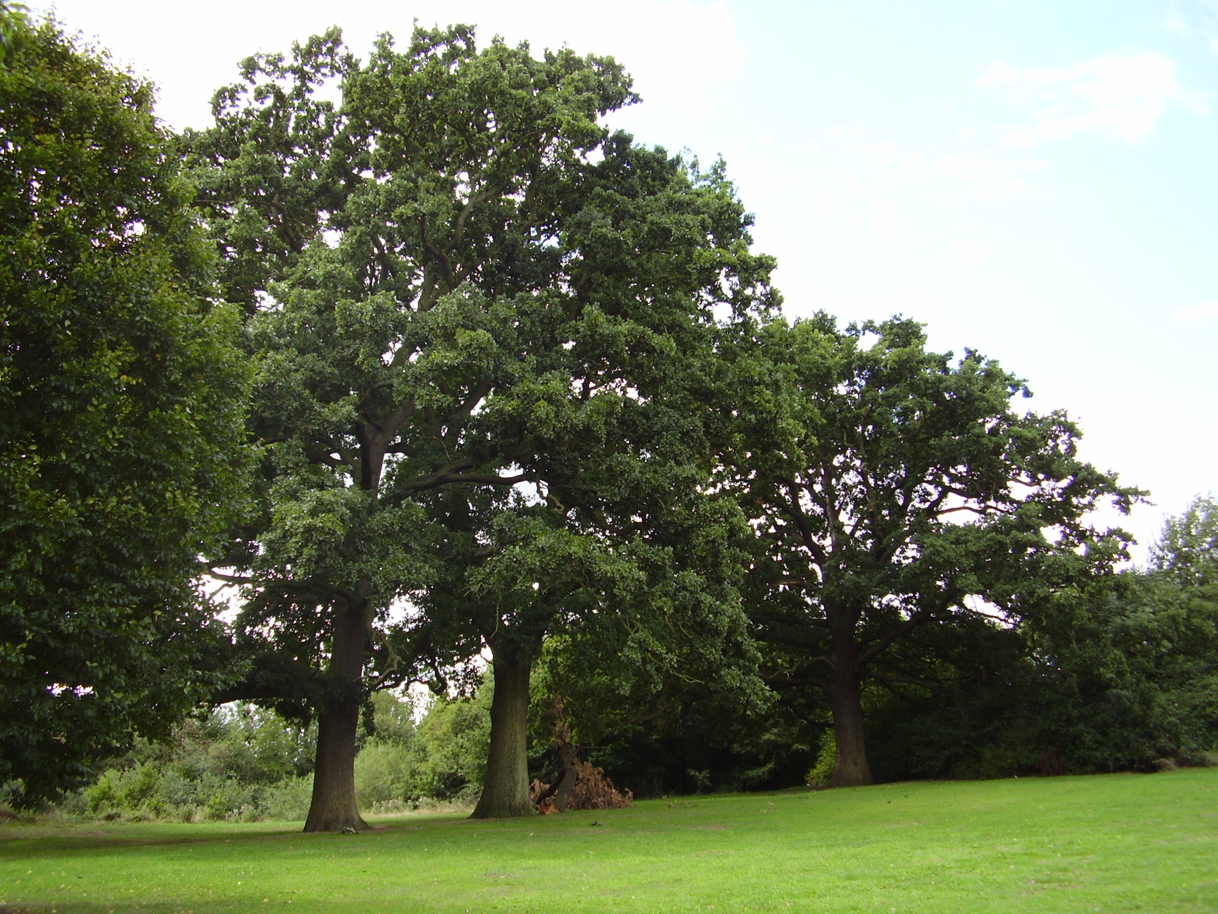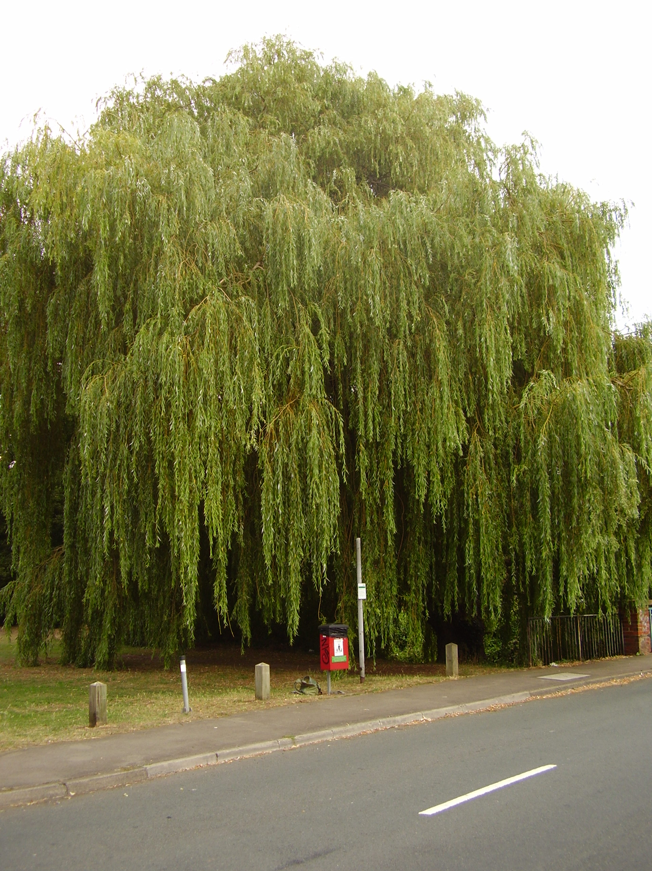

3 Veteran oaks on Woosehill side of The Emm Weeping willow
not far from the supermarket. Originally planted (salix X chrysochoma)
in a line, probably to mark a boundary of some at the Bridge in Meadow Road
sort. Does anybody have any information?

1020 trees have been recorded so far by members of the Wokingham District Veteran Tree Association. With the new software available it is hoped to produce a map of the recorded trees along the Emm. If you would like to know more or have information contact The Chairman, Barbara Stagles bstagles@btinternet.com.

NB Wednesday 21st May at 4.30pm, Guided walk at Bluebell Meadow off Robin Hood Way.
Ring 979 0538 for directions.

There are lots of things in the Brook which are not easily seen unless you look very carefully.
A regular monitoring activity for the Friends of the Emm Brook is ‘kick sampling’.
Question: What do the kick samplers find when they ‘kick’ in the Brook?
Answer: Freshwater Invertebrates.

Four of the most common freshwater invertebrates found in The Brook are:

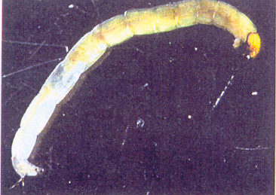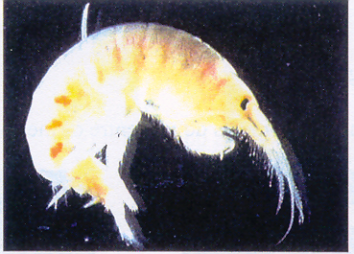
1 Non biting midge larvae 2 Freshwater Shrimp
(Family Chironomidae) (family Gammaridae)

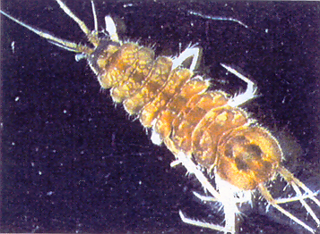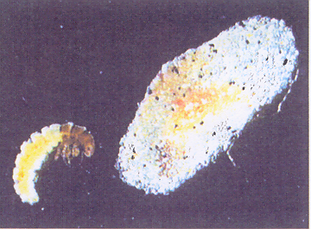
3 Hoglouse 4 Cased Caddis
(family Asilidae ( family hydroptilidae)

Pictures are from The Environment Agency ‘Simple Freshwater Invertebrate Key’

Question: Where does all the information go when we have collected it?

Answer: To the Thames Valley Environmental Records Centre (TVERC)


The TVERC is one in a national network of Local Environmental Records Centres. The records centre collects, collates and makes available information to help people make sound decisions about our natural environment in Oxfordshire and Berkshire. It aims to hold all the available information about the plants, animals, wildlife habitats, and important wildlife and geological sites in Berkshire and Oxfordshire

TVERC: making environmental information available in Berkshire and Oxfordshire. Web site: www.tverc.org

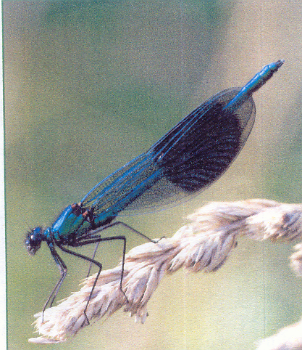
There are offices in Newbury in Berkshire and Woodstock in Oxfordshire.
They can offer expert advice and access to a wide range of skills and experience through a team of ecologists and information specialists.

TVERC is looking for people to become OTTER SPOTTERS. You won’t find otters in the Emm Brook yet, but who knows in the future!? In the meantime TVERC is hoping to create a data base of otter sightings in the Thames Valley Area. If you think you have seen one contact www.tverc.org.

STOP PRESS: Emmbrook Juniors, Year 5, are working on a new information board to be put up in Emmbrook Walk. They hope to have it in place by the summer holidays.
2

